BC COPs NEWS For Citizens on Patrol/Crime Watch Volunteers in BC
FALL 2019 Edition
Welcome to the final edition of the year. I don’t know about you but it’s been an ok fall so far. Despite the colder temperatures, the sunrises and sunsets have been absolutely gorgeous here on the coast.
I have been negligent in not writing more of these but busy with our Canadian COPS group which continues to grow. Well, not so much – well, not really at all. But across the country, it certainly has.
______________________________________________________________________________

I am including this article again because it is so important with more people suffering from PTSD in all walks of life from police, ambulance, fire, our veterans, and others. ______________________________________________________________________________
Vancouver Island Compassion Dogs

Dogs offer support to PTSD sufferers
Ian Jacques / Delta Optimist
August 23, 2018 07:09 AM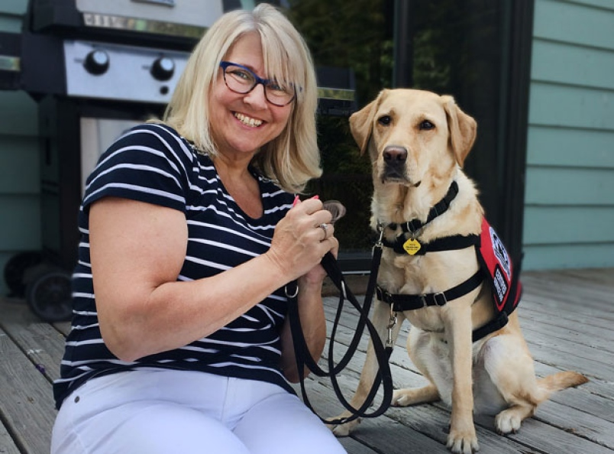
Patti Urquhart with her service dog Tiaa.
Patti Urquhart can’t imagine life without her service dog Tiaa.
The Langley woman, a retired member of the RCMP, and Tiaa are the first Lower Mainland post-traumatic stress disorder team to graduate from a new combined program designed to meet the needs of Canadian Armed Forces and RCMP veterans.
“With Tiaa, she has made me accountable to my own life,” said Urquhart. “Her needing me and me being of service to her while she is of service to me has created such a bond. We go everywhere together. If I’m upset she sits her head in my lap and kisses me and gets me back. I don’t know, honestly, what I would have done a year ago with some of the stuff that I still go through without her.”
Delta’s BC & Alberta Guide Dogs and Vancouver Island Compassion Dogs are amalgamating into a single agency to provide more professionally trained service dogs.
Since inception in 2014, Vancouver Island Compassion Dogs has paired 26 dogs with both military and RCMP veterans on Vancouver Island.
BC & Alberta Guide Dogs was founded in 1996 and breeds, raises and professionally trains guide dogs for blind/visually-impaired individuals and support dogs for children with profound autism. BC & Alberta Guide Dogs has been providing purpose-bred adult dogs and technical support to Vancouver Island Compassion Dogs since its inception.
“BC & Alberta Guide Dogs is thrilled to welcome Vancouver Island Compassion Dogs as part of our team,” said CEO Bill Thornton. “We have been working closely as a team since their inception, so this amalgamation is a natural next step with added services for the Canadian Armed Forces and RCMP veterans suffering from PTSD.”
The amalgamation between the two non-profits allows the PTSD program to double in size and expand to include veterans in the Lower Mainland.
Last Thursday, an event was held in East Ladner to recognize the amalgamation of the two programs. “I met one of the program heads and she told me about this three years ago. I wasn’t at a place in my life then to do anything like this, let alone think I could need a service dog,” added Urquhart. “My GP in Nanaimo told me I would benefit from a service dog as did my psychologist. In January of last year is when I got started.”
Urquhart said she had to put her training on hold for a bit to deal with some family issues, but was heartened by the support she received.“ They just put everything on hold and said that we would pick back up when I was ready,” she said. “They were more than willing to help me out and get me through it at my own pace. Now that I have moved here to the Lower Mainland, I’m thrilled that the program has expanded and I still have all my connections to Vancouver Island. You go into the program very alone, but you come out with not only a dog you love and they love you, but a whole family of support.”
Visit vicompassiondogs.ca/program to learn more.
Here is hot tip for you, your family, and others who have been contacted and hopefully not been scammed at any point. It’s copied from Nanaimo RCMP and should be of interest.

CRA scam back but with a twist
Nanaimo
2019-11-07 15:10 PST
File # 2019 CRA scam is back
The Nanaimo RCMP is advising the public that the notorious CRA scam is back in full force. Dozens of calls have been received throughout Nanaimo and reported to the local detachment. Fortunately, none of those reported, have fallen prey to this scam.
In this latest version of the CRA scam, the intended target receives a phone call from what appears to be a federal government agency, (i.e. Service Canada, Canada Revenue, CRA, Canadian Anti-Fraud Centre) to name just a few. The caller then leads you to believe your SIN card has been compromised, and it is necessary for you to provide the caller your actual card number. It is a scam, simply hang up.
In the other version, the caller tells you that you owe money to the CRA or that you are eligible to receive a cash refund. For those owing money, the caller tells you that your local police agency will call within the hour. Sure enough, the target receives the phone call but it is not actually from the police. The caller has simply spoofed the phone number to make you believe it is from your police agency. They may also try to convince you to provide your credit card number or that you must pay off the amount, by purchasing gift cards or bitcoins. They may also threaten you with being arrested. It is a scam, simply hang up.
Many of these calls originate from call centres in South Asia and in some cases, you can actually hear other scammers making the same calls to other targets. Most callers are also reading from a script.
If you are a victim of a fraud, meaning you have lost money or given out personal information, that could impact you financially, please follow these steps:
Step 1: Gather all information about the fraud. This includes documents, receipts, copies of emails and/or text messages.
Step 2: Contact the Canadian Anti-Fraud Centre toll free at 1-888-495-8501 or through the Fraud Reporting System (FRS).
Step 3: Report the incident to the financial institution where the money was sent (e.g., money service business such as Western Union or MoneyGram, bank or credit union, credit card company or internet payment service provider).
Step 4: If the fraud took place online through Facebook, eBay, a classified ad such as Kijiji or a dating website, be sure to report the incident directly to the website. These details can be found under "report abuse" or "report an ad."
Step 5: Victims of identity fraud should place caution flags on all their accounts and report to both credit bureaus, Equifax and TransUnion.
As with any scam, if you have not provided personal information or lost any money, you do not need to contact your local police. Please report it to the Canadian Anti- Fraud Centre online at www.antifraudcentre.ca or by calling 1-888-495-8501
Released by
Cst. Gary O'Brien
Media Relations Officer
Community Policing Services, Nanaimo
nanaimo.rcmp.ca
______________________________________________________________________________
______________________________________________________________________________

As I stated at the beginning, the CCOPA ( Canadian Citizens On Patrol Association) is moving forward in several areas including interest in Saskatchewan and New Brunswick. For anyone new, this Association is made up of representatives of each province where there is a provincial COPs group, some fully functional and some wavering ( BC).
You should check out our website www.ccopa.ca for all the details. If you want to see how this all works, check out the most involved province Alberta. At last report, they had 76 groups who were all societies and part of the Alberta provincial body (ACOPA). They are very active and can provide short videos which were professionally completed as well as the iPatrol app when out patrolling. Remember when we had our conferences? This is what Alberta is providing. They have a strong connection with “K” Division who are very comfortable with the groups being societies, so very different from BC.
Seems most provinces, Yukon, and NWT have some connection to our group and that’s great. The difficult part is keeping the liaison officers long enough to enjoy them and them us.
I note several detachments who have ‘RCMP Volunteers’ instead of a COPs group but who in fact do most of the same things that we did as COPs members but who don’t patrol covertly but rather are restricted to driving marked vehicles owned by the City. So while that tends to advertise yourself, it doesn’t seem to fit the description of eyes and ears as it used to do.
_____________________________________________________________________________________
Noticing an increase in bike thefts in your community. Well, with the increase in bike use, so goes the increase in bike thefts. Nanaimo provides many great on trial and off trail riding opportunities and to combat, Nanaimo is joining and promoting the 529Garage program.
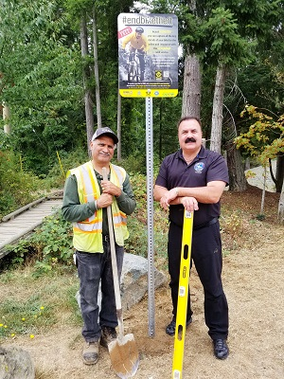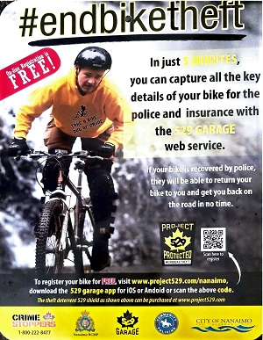
The Nanaimo RCMP is pleased to announce a recent partnership forged between the City of Nanaimo, Nanaimo and District Crime Stoppers and 529 Garage aimed at combating bike theft in the City of Nanaimo. With funding received from the local Crime Stoppers program, the City of Nanaimo installed dozens of Garage 529 registration signs in high visibility locations along the E&N, Parkway trails, Westwood Lake, Beban bike park and a variety of other key locations, designed for easy access for bike riders.
The signs promote free registration on the Garage 529 app and registration takes just 5 minutes. Police take in hundreds of bikes each year and very few make there way back to the rightful owner. However, bikes that are registered on the app are checked against the Garage 529 registry on a regular basis. The end result is people are getting their stolen bikes returned to them, said Dave Cusson, Community Policing Co-ordinator for the Nanaimo RCMP.
How does it work? Well, all of you have to do is scan the QR code on one of the signs with a smart phone or android product, and it connects you directly to the registration page. By using your phone to take pictures of your bike, the app captures all the pertinent information about your bike, such as the make, model, colour and serial number. If a registered bike is stolen the owner of the bike can flag the app and bike owners in the area will be sent an alert. In addition, the bike owner will have all the necessary information for the police when making a report. Anti-theft registration shields are also available from the Garage 529 website for purchase. Shielded bikes show potential thieves, the Police or anyone that finds a bike that it is registered.
The word on the street is bike thieves have no interest in stealing bikes which display the 529 Garage shield. That tells us the program is working. Hopefully, these colourful signs will draw more and more bike enthusiasts to the app and take the 5 minutes and register their bike, said Cusson.
The Garage 529 app has become the largest bike registry in the world. The Nanaimo RCMP embraced this theft prevention platform 4 years ago and is seeing great success. For more information on this App please visit www.project529.com or download it for free on your smart device.
Released by Cst. Gary O'Brien
Media Relations Officer
Community Policing Services, Nanaimo
nanaimo.rcmp.ca
303 Prideaux St, Nanaimo, BC, V9R 2N3

So there you have it. I am always connected with our Canadian volunteers across Canada but need your support to revive our provincial group. Seems that “E” Division is not our friend in promoting COPs and of course the BC Crime Prevention Association continues to avoid this idea and provide no guidance or money to make such an organization strong. Please stay in touch. If you all could send me the name and email address of your Superintendent and Liaison Officer, that would be appreciated.
Good day. Be safe on the roads.
Brian
This newsletter is published for the benefit of volunteers in Citizens on Patrol and Crime Watch programs in BC. The views or comments do not reflect those of police or other Citizens on Patrol or Crime Watch organizations. Articles/pictures about your group at an event can be sent to me at bcornborough@shaw.ca. Keep your Citizens on Patrol/Crime Watch group strong in your community! __________________-----

